|  |  |  |  |
| --- | --- | --- | --- |
| **F:\Learning bugs\Foundation Subjects\Dolly the Fly - Science.jpgLyng Primary School Knowledge Organiser** | | | |
| **Topic:** | **Science  Materials state of Matter** | Year 4 | Spring |

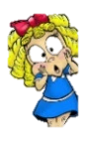/

**What should I already know?**

* Why some materials are used for certain purposes because of their properties.
* That materials can be classified based on their properties.
* The water cycle, and the processes of evaporation, condensation and precipitation.

Matter makes up our physical universe. The matter on Earth, has three states: solid, liquid or gas.

|  |  |
| --- | --- |
| **What Step On and Goldilocks words will I use?** | |
| **Spelling** | **Definition** |
| Condensation | Small drops of water which form when water vapour or steam touches a cold surface, such as a window. |
| Cooling | Lowering the temperature of something. |
| Evaporation | To turn from liquid into gas; pass away in the form of vapour. |
| Freeze | Liquid turns to a solid during the freezing process |
| Freezing | If a liquid or a substance containing a liquid freezes, it becomes solid because of low temperatures. |
| Freezing point | The freezing point of a particular substance is the temperature at which it freezes. The freezing point of water is 0o C. |
| Gas | A form of matter that is neither liquid nor solid. A gas rapidly spreads out when it is warmed and contracts when it is cooled. |
| Heating | Raising the temperature of something. |
| Liquid | In a form that flows easily and is neither a solid nor a gas. |
| Melt | This is when a solid changes to a liquid. |
| Melting | To change from a solid to a liquid state through heat or pressure. |
| Melting point | The melting point of a particular substance is the temperature at which it melts. |
| Particles | A tiny amount or small piece. |
| Precipitation | Rain, snow, sleet, dew, etc, formed by condensation of water vapour in the atmosphere process a series of actions used to produce something or reach a goal. |
| Properties | The ways in which an object behaves. |
| Solid | Having a firm shape or form that can be measured in length, width, and height; not like a liquid or a gas. |
| States of matter | Materials can be one of three states: solids, liquids or gases. Some materials can change from state to another and back again. |
| Temperature | A measure of how hot or cold something is |
| Vibrations | When something vibrates, it shakes with repeated small, quick movements |
| Water Cycle | The process by which water on the earth evaporates, then condenses in the atmosphere, and then returns to earth in the form of precipitation. |
| Water vapour | Water in the gaseous state, esp when due to evaporation at a temperature below the boiling point. |

|  |
| --- |
| **Investigate!** |
| * Group materials according to their states. * Explain and demonstrate the particle structure of solids, liquids and gases. * Explore the effect of temperature on substances such as chocolate. Compare their melting points and record them in a table. * Research the temperature at which materials change state, for example, when iron melts or when oxygen condenses into a liquid. * Observe and record evaporation over a period of time * Analyse and interpret different forms of data (tables, graphs) to show the effects of temperature on states of matter. * Draw a diagram to show the process of the water cycle. * Present what you know about the water cycle using a variety of skills using appropriate vocabulary. |

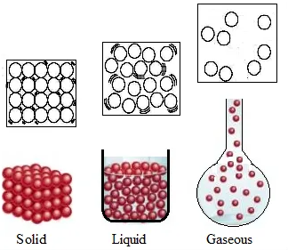

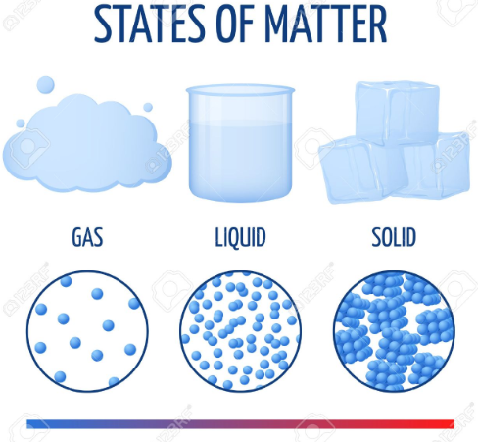

|  |
| --- |
| **Enquiry Questions** |
| * How do we identify solids using their properties? * How do you describe the melting and freezing states? * How to describe condensing and evaporating conditions? * How to describe the different stages of the water cycle? * How to describe how temperature affects evaporation rates and the water cycle? |

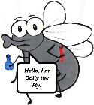

**What will I know by the end of the unit?**

|  |  |
| --- | --- |
| What is a particle? | * Particles are what materials are made from. * They are so small that we cannot see them with our eyes. * The properties of a substance depend on what its particles are like, how they move and how they are arranged * Particles behave differently in solids, liquids and gases |
| What is a solid? | * In the solid state, the material holds its shape. * Solids have vibrating particles which are tightly packed in and form a regular pattern. * This explains the fixed shape of a solid and why it doesn’t pour. * Solids always take up the same amount of space. |
| What is a liquid? | * In the liquid state, the material holds the shape of the container it is in. * This means that liquids can change shape, depending on the container. * Liquids have particles which are close together but random. * Liquid particles can move over each other. * Liquids can be poured. |
| What is a gas? | * In the gas state, particles can escape from open containers. * Gases have particles which are spread out and move in all directions. |
| What happens to the particles in water when it is heated or cooled? | * When water (in its liquid form) is heated, the particles start to move faster and faster until they have enough energy to move about more freely. The water has evaporated into a water vapour. * When water is cooled, the particles start to slow down until a solid structure (ice) is formed. The water has frozen. * The temperature at which water turns to ice is called the freezing point. This happens at 0o C. |
| What is the water cycle? |  |

|  |  |  |  |
| --- | --- | --- | --- |
| **F:\Learning bugs\Foundation Subjects\Dolly the Fly - Science.jpgLyng Primary School Knowledge Organiser** | | | |
| **Topic:** | **Science materials state of matter** | Year 4 | Spring |

|  |  |  |
| --- | --- | --- |
| 1. If you put something in a container,  how would you tell if it was a liquid? | **S** | **E** |
| a) It becomes the same shape as the container |  |  |
| b) It skins to the bottom of the container and it takes it's shape |  |  |
| c) It fills the container from the bottom |  |  |
| d) All of the above |  |  |

|  |  |
| --- | --- |
| **4. Match the material to its melting point.** | |
| **S** | **E** |

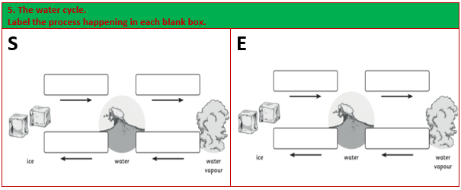

|  |  |  |
| --- | --- | --- |
| 2. Write true or false for these statements. | **S** | **E** |
| a) Gases can be squashed |  |  |
| b) Solids can change shape on their own |  |  |
| c) Gravity keeps liquids at the bottom of a container |  |  |
| d) Gases don’t weigh anything |  |  |

|  |  |  |
| --- | --- | --- |
| 3. How do these particles behave? | **S** | **E** |
| a) Solid | **_________________ _________________**  **_________________** | **_________________ _________________**  **_________________** |
| b) Liquid | **_________________ _________________**  **_________________** | **_________________ _________________**  **_________________** |
| c) Gas | **_________________ _________________**  **_________________** | **_________________ _________________**  **_________________** |